EXPERIMENT NO: 1
Roll No:240701360 Name:D.Nikhilesh
Comparative Study of Low-Code Development versus Traditional Application Development Approaches

Aim
To study and compare the Traditional Application Development approach with the Low-Code Development approach based on their development process, coding effort, development time, cost, flexibility, maintenance, deployment, and overall efficiency.

Introduction to Traditional Application Development
Traditional application development is the conventional method of building software applications by writing source code manually using programming languages such as Java, Python, C#, C++, PHP, or JavaScript. It follows the Software Development Life Cycle (SDLC), where each phase is completed systematically.
The traditional approach requires skilled software developers who write, test, debug, and maintain the application's source code. Since every functionality is coded manually, this method provides complete control over the application but requires more time, effort, and resources.
Traditional development is commonly used for:
- Enterprise Applications
- Banking Systems
- Hospital Management Systems
- Airline Reservation Systems
- E-commerce Platforms
- Embedded Systems

Characteristics
- Manual coding
- High flexibility
- Highly customizable
- Better performance
- Suitable for complex applications
- Longer development cycle
Advantages
- Complete control over the application
- Highly secure
- Excellent scalability
- Better optimization
- Supports complex business logic
- Independent of platform limitations
Disadvantages
- Time-consuming
- Higher development cost
- Requires experienced developers
- Longer testing phase
- Maintenance is difficult
- Slow deployment
Introduction to Low-Code Development
Low-Code Development is a modern software development approach where applications are developed using visual interfaces, drag-and-drop components, pre-built templates, workflows, and minimal coding.
Instead of writing thousands of lines of code, developers configure application components visually. Low-code platforms automatically generate most of the underlying code, allowing faster application development.
Popular Low-Code Platforms include:
- Zoho Creator
- Microsoft Power Apps
- Mendix
- OutSystems
- Appian
Low-code development is mainly used for:
- Business Applications
- Workflow Automation
- CRM Systems
- HR Management Systems
- Internal Company Portals
- Mobile Applications
Characteristics
- Visual development
- Drag-and-drop interface
- Minimal coding
- Rapid development
- Easy deployment
- Easy maintenance
Advantages
- Faster development
- Lower development cost
- Easy to learn
- Quick deployment
- Less coding
- Built-in testing and deployment
- Increased productivity
Disadvantages
- Limited customization
- Platform dependency
- Licensing cost
- Performance limitations
- Less suitable for highly complex systems
- Vendor lock-in

Diagram for Stages in Traditional Application Development
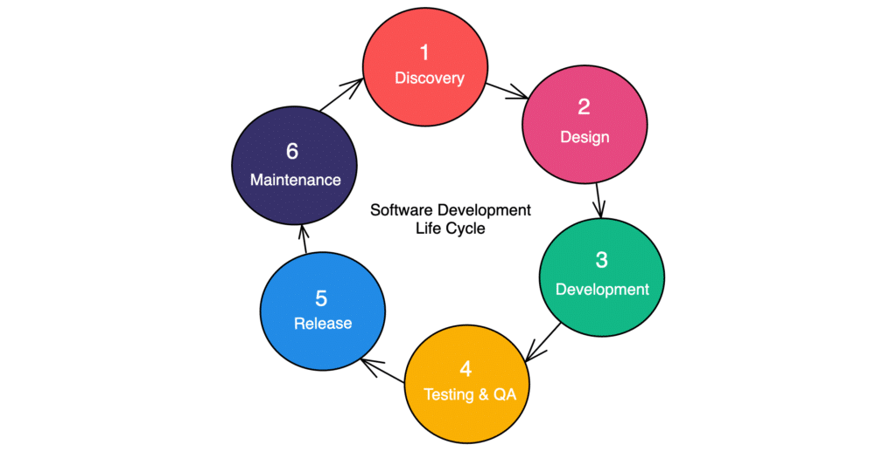

Explanation
Requirement Analysis
- Gather customer requirements.
System Analysis
- Analyze feasibility and system requirements.
System Design
- Design database, architecture, and UI.
Coding
- Develop application using programming languages.
Testing
- Find and fix bugs.
Deployment
- Install application for users.
Maintenance
- Fix issues and provide updates.

Diagram for Steps in Low-Code Development
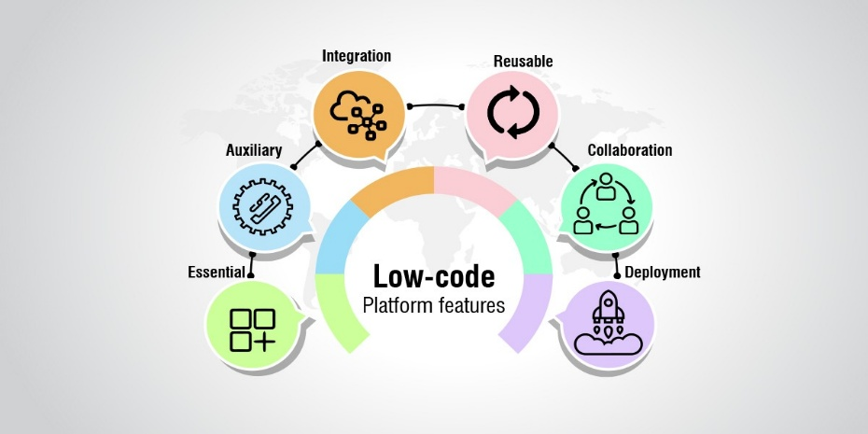

Gather Requirements
- Understand business needs.
Visual Design
- Create UI using drag-and-drop tools.
Configure Logic
- Configure workflows and automation.
Database Integration
- Connect data sources.
Testing
- Verify application functionality.
Deployment
- Publish application.
Maintenance
- Monitor performance and make updates.

Comparative Analysis
Parameter | Traditional Development | Low-Code Development
Development Method | Manual Coding | Visual Development
Programming Required | Extensive | Minimal
Development Speed | Slow | Very Fast
Coding Effort | High | Low
Learning Curve | Difficult | Easy
Cost | High | Low
Development Time | Months | Days or Weeks
Flexibility | Very High | Moderate
Customization | Excellent | Limited
Maintenance | Complex | Easy
Testing | Manual & Automated | Mostly Built-in
Deployment | Time-consuming | Rapid
Scalability | Excellent | Platform Dependent
Security | High | Depends on Platform
Suitable For | Large & Complex Systems | Small to Medium Business Apps
Team Required | Large Development Team | Small Team
Productivity | Moderate | High
Updates | Manual | Easy
Integration | Custom APIs | Built-in Connectors
Examples | Banking, ERP, Healthcare | CRM, HRMS, Workflow Apps

Result
The comparative study concludes that Traditional Application Development provides greater flexibility, scalability, customization, and control, making it suitable for large-scale and highly complex applications. However, it requires more development time, experienced programmers, and higher development costs.
On the other hand, Low-Code Development enables rapid application development using visual tools with minimal coding. It significantly reduces development time, cost, and maintenance effort, making it ideal for business applications, workflow automation, and quick software delivery. Although low-code platforms may have some limitations in customization and platform dependency, they greatly improve productivity and accelerate software development.

